8.111: a) The tension in the rope at the point where it is suspended from the table is 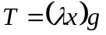, where x is the length of rope over the edge, hanging vertically. In raising the rope a distance 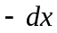, the work done is 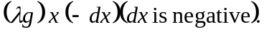 The total work done is then

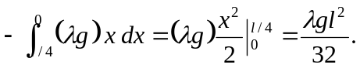

b) The center of mass of the hanging piece is initially a distance l/8 below the top of the table, and the hanging weight is 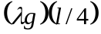, so the work required to raise the rope is 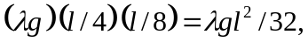 as before.

